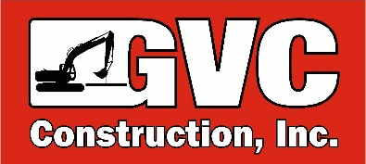

CONSTRUCTION LABORER/PIPE LAYER

A Construction Laborer’s position includes various manual tasks associated with construction operations.

JOB RESPONSIBILITIES
- Water & Sewer
  - Installation of Water Mains
  - Installation of Sewer Mains
  - Installation of Drain Lines
  - Service Connections
  - Utility Locating
  - Site Cleanup
  - General Labor
  - Use of surveying and pipe laser equipment
- Concrete
  - Formwork and reinforcing
  - Placing Concrete
- Must have knowledge and understanding of the procedures to use the tools and equipment safely and properly
- Organize and maintain tool trailers in a neat and orderly fashion

QUALIFICATIONS
- Must have 2-5 years of Heavy/Civil Construction experience
- CDL is preferred
- 2A Hydraulics License is preferred
- Completed OSHA 10 Training is preferred
- Must be able to follow verbal instructions
- Maintain good health status and flexibility to bend, push, pull, stoop and/or twist
- Must be able to perform strenuous work in varying weather conditions
- Team player and with strong interpersonal and verbal skills
- Reliance on experience and judgment to plan and accomplish goals
- Dedicated and hard working
- Show quality in everything you do
- Lead with integrity while producing high quality work
- Experience in underground utilities is preferred.

BENEFITS
- Health & dental Insurance
- Paid Vacations
- 401K with employer match
- Profit Sharing

