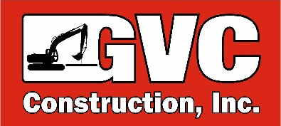

HEAVY EQUIPMENT OPERATOR

A Heavy Equipment Operator’s position includes various tasks associated with construction operations.

JOB RESPONSIBILITIES
- Excavation activities associated with water, sewer, drain, and precast installation.
- Excavation around active buried utilities
- Rigging and Hoisting heavy loads
- Cuts & Fills according to job-site specific survey
- Daily equipment checks and general equipment maintenance
- Understand and comply with all Company safety policies and procedures. Know where all utilities within the work zone are located. Be responsible for your own safety as well as those working in the area
- Cleaning the machines regularly. This includes sweeping the cabs and removing trash daily, cleaning the interior weekly, and lubricating doors and windows bi-weekly

QUALIFICATIONS
- Must possess a minimum of 5 years experience operating heavy equipment.
- CDL is preferred
- 2A Hydraulics License is required
- Completed OSHA 10 Training is preferred
- Must be able to follow verbal instructions
- Maintain good health status and flexibility to bend, push, pull, stoop and/or twist
- Must be able to perform strenuous work in varying weather conditions
- Team player and with strong interpersonal and verbal skills
- Reliance on experience and judgment to plan and accomplish goals
- Dedicated and hard working
- Show quality in everything you do
- Lead with integrity while producing high quality work
- Experience in underground utilities is preferred.

BENEFITS
- Health & dental Insurance
- Paid Vacations
- 401K with employer match
- Profit Sharing

